A Major Project Synopsis on

**Artificially Intelligent Solution to Plant Health Monitoring**

Submitted to Manipal University, Jaipur

Towards the partial fulfillment for the Award of the Degree of

**BACHELORS OF TECHNOLOGY**

In Computers Science and Engineering

2018-2022

By

Aahan Singh Charak

189301024



Under the guidance of

Dr. Aditya Sinha

**Department of Computer Science and Engineering**

**School of Computing and Information Technology**

**Manipal University Jaipur**

**Jaipur, Rajasthan**

**Introduction**

Agriculture plays a very important role in our daily lives. From providing food to everyone, livelihood to the farmers, and raw materials for the industry, agriculture plays an important role in the survival of human beings. Plants play a very vital role in nature. They are one of the forces keeping global-warming away from us. But plants aren’t resistant to diseases. So, it becomes necessary for us to study the diseases occurring in plants, in order to develop measures to prevent and cure them.

Productivity is severely affected by the pathogens, sometimes the results can even be drastic. There have been major uses of technology in solving this problem. Such as the role of image processing and machine learning techniques in plant health monitoring. As seen in Sinha and Shekhawat (2020)[1] plant health monitoring using image processing may be broadly classified into three major steps, i.e. detection, quantification and classification. For detection, quantification and classification of plant diseases quite a lot of work has been carried out, focussing on leaves, stems, roots, fruits etc.[2-4].

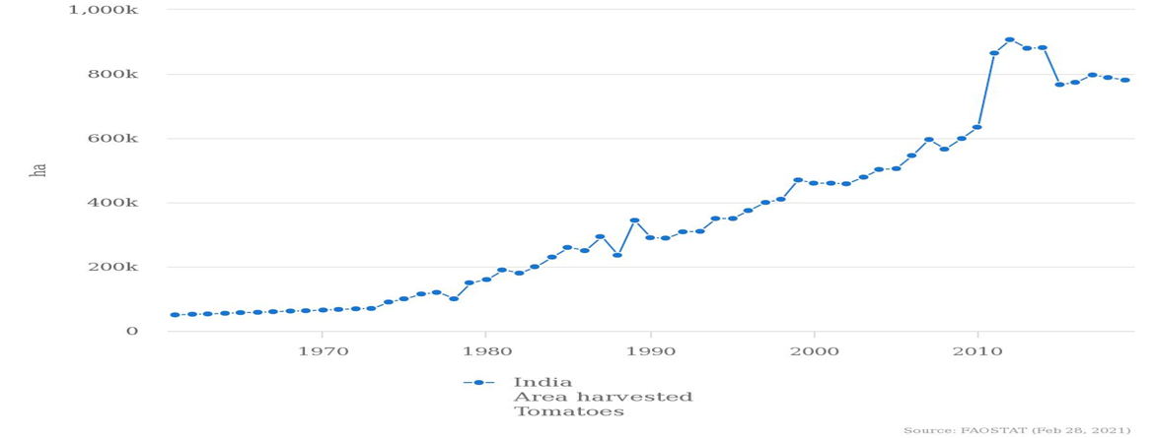

From the above given trend we can clearly see that production takes a dip starting from around late 2014’s. One of the main factors behind this is diseases happening in plants,.

Classification and detection are often incorporated into the same study. This is done by training the machine learning model to also identify healthy leaf images along with the diseased ones. Quantification on the other hand is the severity measurement of infection patterns on the leaves.

Quantification is carried out by first segmenting the diseased portions of the leaves from the healthy portions and then calculating the pixel ratio of diseased pixels to the healthy pixels.

**Motivation**

The main motivation behind taking up this research is the fact that most computational research in the agricultural domain is done separately for detection, classification and quantification. All these independent studies are useful for specific tasks but incorporating them into a single system is very challenging. A computational system which does all of this together would be very useful to the agriculture community. All the tasks can be incorporated in a single system which reduces the time and effort required to carry out these tasks separately using different softwares.

However this is not an easy task. In order to develop a software which performs all these tasks, it is necessary to develop an optimal solution for all of the above mentioned tasks. The overall performance of the software would now depend upon the individual performance of the tasks it performs. So, it is necessary to fine tune them.

We are taking an artificial intelligence or deep learning approach to solve this problem. The problem with vanilla image processing approaches is that even though they are good at segmentation problems, they tend to underperform in classification and detection tasks as compared to the deep learning approaches. Moreover with the availability of new state of the art deep learning networks, it is now very easy to do transfer learning by using pre-trained weights and customizing the network as per our need.

**Statement of Problem**

| Method | Advantages | Disadvantages | References |
| --- | --- | --- | --- |
| AlexNet and GoogleNet for Classification | Pre-trained architecture, smaller parameter size than most pre-trained networks.  Worked good on training images..(which were in controlled en | Didn’t work well on new test images.  Focussed only on classification and not severity measurement | Mohanty et al.[5] |
| Inception V3 based on GoogleNet for Detection and Classification | Pre-trained architecture used.  Deeper network,  Computationally less expensive. | Less generalizability  Focussed only on classification and not severity measurement | Ramcharan et al.[6] |
| Quantifying the severity of diseases in plants by using image processing on images lying in the visible range of electromagnetic spectrum. | We can work over large datasets so our work can cover a large area.    Tools like neural networks can be used to automate quantification process thus saving our time.    Gives very high accuracy if measurements are being performed under controlled conditions. | Highly inaccurate if used in on-field analysis.  Shadows and light can interfere with proper quantification.  No focus on classification | Bock et al.[7] |
| HSI/MSI Image Analysis | We can analyse images which are outisde the visible band.  We can segment and detect disease patterns which otherwise would be invisible to the naked eye.  MSI/HSI images deal with the wavelengths associated with the light waves from diseased regions. This provides us with more insights. | Factors like solar altitude,illumination and dust can be problematic while performing measurements.  Motion of crop due to factors like wind, storms etc.. can also cause errors.  No focus on classification | Bock et al.[7] |

**Methodology/ Planning of work**

1. **Training Phase**

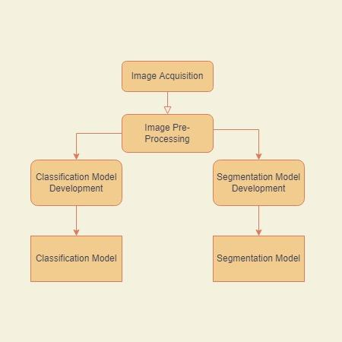

1. **Inference Phase**

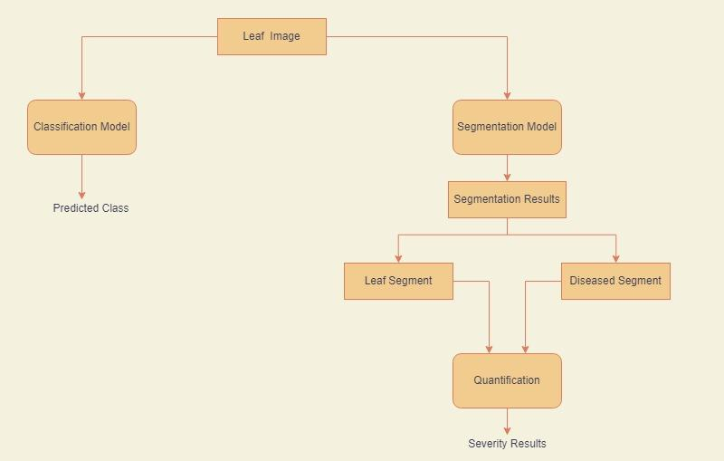

**Facilities required for proposed work:**

**Processor:** Minimum 1 GHz; Recommended 2GHz or more

**Hard Drive:** Minimum 32 GB; Recommended 64 GB or more

**Memory (RAM):** Minimum 4 GB; Recommended 8 GB or above

**Graphical Processing Unit (GPU):** We will be using external kaggle/google collab gpu as our computer is not that computationally powerful. Kaggle provides access to Nvidia **K80** GPUs in kernels.

**Bibliography/References**

[1] Sinha, Aditya, and Rajveer Singh Shekhawat. "Review of image processing approaches for detecting plant diseases." IET Image Processing 14.8 (2020): 1427-1439.

[2] Sinha, Aditya, and Rajveer Singh Shekhawat. "Olive spot disease detection and classification using analysis of leaf image textures." Procedia Computer Science 167 (2020): 2328-2336.

[3] Sinha, Aditya, and Rajveer Singh Shekhawat. "A novel image classification technique for spot and blight diseases in plant leaves." The Imaging Science Journal 68.4 (2020): 225-239.

[4] Sinha, Aditya, and Rajveer Singh Shekhawat. "Detection, quantification and analysis of neofabraea leaf spot in olive plant using image processing techniques." 2019 5th International Conference on Signal Processing, Computing and Control (ISPCC). IEEE, 2019.

[5] Mohanty, S.P.; Hughes, D.P.; Salathé, M. Using deep learning for image-based plant disease detection. Front. Plant Sci. 2016, 7, 1419

[6] Ramcharan, A.; Baranowski, K.; McCloskey, P.; Ahmed, B.; Legg, J.; Hughes, D.P. Deep Learning for Image-Based Cassava Disease Detection. Front. Plant Sci. 2017, 8, 1852

[7] Bock, C.H., Barbedo, J.G.A., Del Ponte, E.M. et al. From visual estimates to fully automated sensor-based measurements of plant disease severity: status and challenges for improving accuracy. Phytopathol Res 2, 9 (2020). https://doi.org/10.1186/s42483-020-00049-8